**Projeto Nexus**

AS-BUILT



**PREVI**

Rio de Janeiro, 01 de Agosto de 2013.

INDICE

1. Informações Gerais 4

1.1 Responsáveis 4

1.2 Dados do Cliente 4

2. Controle do documento 5

3. Plano de comunicação 6

3.1 Fluxo de Comunicação 6

3.1 Processo de escalonamento 6

4. Objetivo 7

5. Escopo 8

6. Rede anterior 9

7. Solução proposta 10

7.1.1 Solução de comutação de pacotes no núcleo da rede 10

7.1.2 Virtual Device Contexts (VDC) 11

7.2 Topologia L3 12

8. Topologia L2 13

9. Virtualização do sistema (VDC) 14

10. Especificação de hardware 15

11. Interfaces 16

11.1.1 Interfaces NEXUS_01 16

12. Configuração das VLANs 17

13. Roteamento 18

14. Configuração de portas FEX 19

15. Configuração de portas trunks 20

16. Configuração de portas de acesso 22

17. Mapeamento de portas do switches. 23

18. Gerenciamento 26

18.1 SSH 26

18.2 Log de eventos (Syslog) 26

18.3 SNMP 26

18.4 NTP 26

19. Solução de gerenciamento DC-NM 27

20. Backup da configuração 34

20.1 NEXUS_01 34

20.2 NEXUS_01-VDC1: 35

# Informações Gerais

|  |  |
| --- | --- |
| TEN SISTEMAS E REDES | |
| Rua São Bento, 9/5°andar - Centro - Rio de Janeiro - RJ | |
| CEP: 20090-010 | |
| Tel.: (021) 3906-7777 | Fax: (021) 3906-7778 |

## Responsáveis

|  |  |
| --- | --- |
| Consultores Técnicos | Heron Brito  heron@ten.com.br |
| Coordenador de Projetos | Otávio Pettersson  [otavio@ten.com.br](mailto:otavio@ten.com.br) |
| Diretor de Serviços | Marcelo Wajnsztok  [marcelow@ten.com.br](mailto:marcelow@ten.com.br) |
| Gerente de Contas | João Saramago  [saramago@ten.com.br](mailto:angela@ten.com.br) |

## Dados do Cliente

|  |  |
| --- | --- |
| Cliente | PREVI  Caixa de Previdência dos Funcionários do Banco do Brasil |
| Informações de Contato | Elizeu Filho  [elizeuf@previ.com.br](mailto:baena@gestal.com.br)  Tel.: (21) 3870-1564  Amaro Nogueira  [amaro.nogueira@previ.com.br](mailto:amaro.nogueira@previ.com.br)  Tel.: (21) 3870-1577 |

# Controle do documento

Localização do Documento

Este documento pode ser encontrado na rede corporativa da TEN, contate o Gerente de Projetos para maiores informações.

Histórico

|  |  |  |  |
| --- | --- | --- | --- |
| Data da revisão | Ver/Rev | Resumo da mundança | Autor |
| 29/07/2013 | 0.1 | Criação do esqueleto e versão inicial | Heron |
| 01/08/2013 | 0.2 | Criação de conteúdo | Heron |
| 05/08/2013 | 0.3 | Adição de conteúdo | Heron |
| 07/08/2013 | 1.0 | Finalização do documento | Heron |
|  |  |  |  |

Aprovações

|  |  |  |
| --- | --- | --- |
| Data | Ver/Rev | Nome |
| 07/08/2013 | 1.0 | Marcelo W. |
|  |  |  |
|  |  |  |

# Plano de comunicação

## Fluxo de Comunicação

O Gerente de Projetos foi o ponto focal para a resolução de problemas, gerenciamento de pontos críticos, cronogramas e status. Contudo, os membros da equipe da TEN interagiram com os especialistas da PREVI para entendimentos técnicos e requerimentos. O Gerente de Projeto, Otávio Petterson, foi copiado em todas as comunicações garantindo que a informação fique atualizada com os pontos focais das equipes envolvidas.

O Sr. Elizeu Filho foi o ponto focal da equipe de TI da PREVI, e foi copiado também em todas as comunicações.

## Processo de escalonamento

Nos casos de incidentes e (ou) eventos que necessitem de tomadas de decisões de alta prioridade em nível executivo, as pessoas envolvidas seguiram fluxo de escalonamento:



# Objetivo

O objetivo deste projeto é substituição da infraestrutura de switches da sala cofre que tem uma arquitetura centralizada e fazendo uso de um volume maior de cabeamento, para um arquitetura utilizando topo de racks de cada fileira. Neste projeto também foi realizada uma atualização tecnológica utilizando-se switches da família Nexus do fabricante Cisco.

Nesta projeto foi migrada a função de switch de núcleo (switch core) do switch Catalyst 6509 para o Nexus 7009.

As conexões de todos os servidores da sala-cofre existentes no Catalyst 6509 foram migradas para a nova solução. Esta faz uso também de switches da linha Nexus 2000 que funcionam como módulos estendidos do próprio switch Nexus 7009, porém instalado fisicamente nos racks próximos aos servidores, simplificando o cabeamento e manutenções.

Este documento visa descrever tecnicamente como ficou implantada esta solução.

# Escopo

A realização das atividades foram delimitadas de acordo com o escopo acordado previamente e alguns ajustes feitos durante o Kick-off do projeto:

1)Serviço de instalação e configuração:

Efetuar a instalação física dos equipamentos que compõe a solução CISCO Unified Fabric (Switch Nexus 7009 e Nexus 2000 Fabric Extender) em topologia TOP OF RACK;

1.1 Integrar a solução com o Switch Core Catalyst 6509E;

1.2 Integrar a solução com os Switchs CISCO Blade 3120X for HP;

1.3 Migrar a função de roteador de camada 3 do atual switch 6509 para o Nexus 7009;

1.4 Passar o conhecimento da instalação efetuada.

2) Escopo do trabalho referente ao seguintes equipamentos:

Um switch Nexus 7009 e seus respectivos módulos, dois Nexus 2232 Fabric Extender, seis Nexus 2248 Fabric Extender, um

Catalyst 6509E e oito Catalyst 3120x blade for HP;

2.1. Apresentação de cronograma de trabalho, detalhado, a ser aprovado por esta PREVI/INFOR/NUINF2.

2.2. Efetuar levantamento antecipado das configurações dos equipamentos relacionados acima e providenciar a sua conversão/adaptação a nova versão de hardware ora em aquisição.

2.3. Apresentação dos scripts e/ou arrazoado das configurações para aprovação por esta PREVI/INFOR/NUINF2, com antecedência mínima de dois dias úteis antes da data de implementação ou etapa do projeto.

2.5. Acompanhar "in loco", por pelo menos por dois dias úteis, após a migração/instalação de cada ente da solução, para resolução imediata de quaisquer problema que venha a surgir oriundo do processo.

2.6. Caso seja necessário, será atualizada a versão do sistema operacional dos switchs.

2.7. Instalação de novo Switch Nexus 7009, para trabalhar em modo redundante, entre as duas placas supervisoras do equipamento.

2.8.Instalação dos Nexus 2232 e 2248 Fabric Extender, conectado-os ao Switch Nexus 7009, conforme definido no cronograma de trabalho.

2.9. Instalação do novo módulo de interfaces 10Ge adquirido para o switch C6509E.

2.10. Configuração de comunicação entre o Switch Nexus 7009 e o Switch 6509E, de forma redundante e com banda agregada.

2.11. Conexão dos oito switchs CISCO Catalyst 3120X for HP.

2.11.1 Caso seja necessário, deverá ser atualizada a versão do sistema operacional dos switchs Catalyst 3120X for HP.

2.12. Apresentação de relatório final dos trabalhos incluindo:

2.12.1. desenhos das topologia anterior e da atualizada.

2.12.2. Scripts de configurações.

2.12.3. Documentação passo-a-passo.

2.12.4. logs de eventos.

2.12.5. Treinamento "hands on"

2.13. Novas funcionalidades dos produtos deverão ser apresentadas e configuradas para operação normal.

# Rede anterior

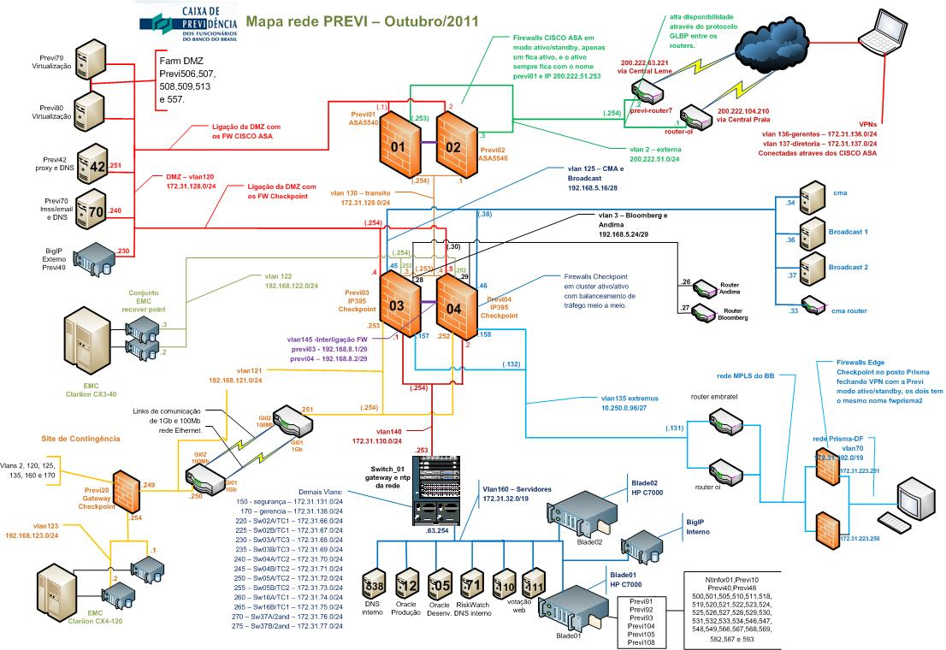

No ambiente incialmente encontrado, a rede da PREVI possuía seu núcleo dividida em 3 camadas de ativos principais. Sendo a primeira proteção de perímetro feita através de um cluster de Firewall Cisco ASA, a segunda camada é composta por um cluster de Firewall Checkpoint e uma terceira camada que tinha o switch Cisco 6509 como responsável e abrigava os principais servidores e estações do campus.

Os servidores e os switches de acesso eram conectados diretamente ao switch core.

# Solução proposta

### Solução de comutação de pacotes no núcleo da rede

A linha de switches Nexus 7000 permite a criação de um fundação solida para as necessidades da próxima geração de “Unified Fabric” de um centro de dados com redes ethernet e fibre channel numa única solução. Também é plataforma robusta para atuar como núcleo de redes IP de alta performance. A série de Switches Modulares Cisco Nexus 7000 traz um completo pacotes de funcionalidade através de seu sistema operacional NX-OS. Possui alta densidade de portas 10 Gigabit Ethernet para centro de dados. Sua plataforma foi desenhada para a maioria dos ambientes de missão crítica.

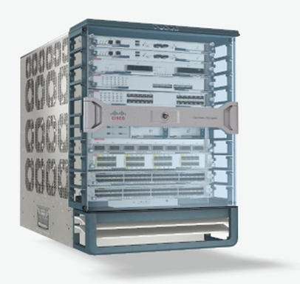

O Cisco Nexus 7000 foi desenhado seguindo 3 princípios básicos:

. Infraestrutura Escalável: Virtualização, uso eficiente de energia e refrigeração, alta densidade e performance são características que permitem um crescimento eficiente do datacenter.

. Continuidade Operacional: A arquitetura do Cisco Nexus integra o hardware, o NX-OS e o gerenciamento para suportar ambientes com tempo de parada zero.

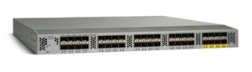

. Flexibilidade de Transporte: Permite novas adoções de inovações de tecnologias de redes como:

- Cisco Overlay Transport Virtualization (OTV)

- Cisco FabricPath

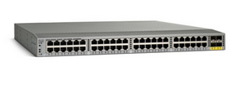

- Fibre Channel over Ethernet (FCoE)

- Cisco Locator/D Separation Protocol (LISP)

- Cisco IOS Multiprotocol Label Switching (MPLS)

### Virtual Device Contexts (VDC)

O software Cisco NX-OS suporta VDC (Virtual Device Context) que permite segmentar um equipamento físico em múltiplos dispositivos lógicos provendo isolamento em caso de falhas, isolamento do gerenciamento, isolamento da alocação de endereços, diferentes domínios de serviços e gerencia de recursos adaptáveis. Um VDC roda como uma entidade separada logicamente e mantem seu único conjunto de processos de software rodando e seus próprios arquivos de configuração. Cada roteador virtual possui sua própria base de informações de roteamento (RIB) e protocolos de roteamento.

## Topologia L3

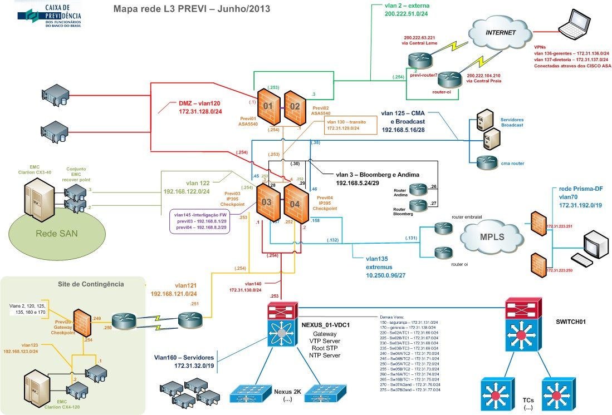

* Descrever características da rede anterior

- Implementação de solução de controle de SPAM

* Ativação de 1 Cisco IronPort C670

Na nova topologia foi adicionado um switch Nexus 7000 e oito switches Nexus 2000. O switch Nexus 7000 passou a atuar como switch de núcleo (core) e os switches Nexus 2000 como switches de servidores e fisicamente próximos aos mesmos. Já o switch 6509 passou a atuar como um switch de distribuição para a camada de acesso.

# Topologia L2

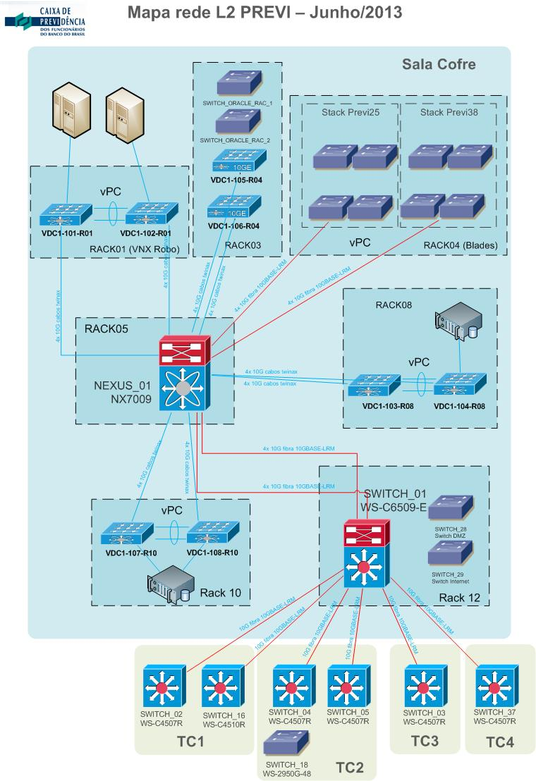

# Virtualização do sistema (VDC)

O projeto foi feito já virtualizando o sistema principal que executa as funções do switch, o que permite a criação futura de novos sistemas virtuais paralelos, escalando assim a solução existente. Foram criados dois contextos sendo uma o contexto “admin” para gerenciamento do chassis e um contexto “VDC1” que é o contexto onde executa praticamente todas as funções da solução implantada.

*vdc NEXUS_01 id 1*

*cpu-share 5*

*limit-resource vlan minimum 16 maximum 4094*

*limit-resource monitor-session minimum 0 maximum 2*

*limit-resource monitor-session-erspan-dst minimum 0 maximum 23*

*limit-resource vrf minimum 2 maximum 4096*

*limit-resource port-channel minimum 0 maximum 768*

*limit-resource u4route-mem minimum 96 maximum 96*

*limit-resource u6route-mem minimum 24 maximum 24*

*limit-resource m4route-mem minimum 58 maximum 58*

*limit-resource m6route-mem minimum 8 maximum 8*

*limit-resource monitor-session-inband-src minimum 0 maximum 1*

*vdc VDC1 id 2*

*limit-resource module-type f2*

*allow feature-set fex*

*cpu-share 5*

*allocate interface Ethernet3/1-48*

*allocate interface Ethernet4/1-48*

*boot-order 1*

*limit-resource vlan minimum 16 maximum 4094*

*limit-resource monitor-session minimum 0 maximum 2*

*limit-resource monitor-session-erspan-dst minimum 0 maximum 23*

*limit-resource vrf minimum 2 maximum 4096*

*limit-resource port-channel minimum 0 maximum 768*

*limit-resource u4route-mem minimum 8 maximum 8*

*limit-resource u6route-mem minimum 4 maximum 4*

*limit-resource m4route-mem minimum 8 maximum 8*

*limit-resource m6route-mem minimum 5 maximum 5*

*limit-resource monitor-session-inband-src minimum 0 maximum 1*

# Especificação de hardware



# Interfaces

### Interfaces NEXUS_01



# Configuração das VLANs

As VLAN’s descritas abaixo foram configuradas no Switch core e mantidas em todos os outros switches:



# Roteamento

Como o switch Nexus assumiu a função de gateway das vlans de usuários e do centro de dados, as rotas existentes no switch 6509 foram migradas para ele e as seguintes rotas foram adicionadas:

*ip route 0.0.0.0/0 172.31.130.254*

*ip route 10.1.1.1/32 Null0*

*ip route 10.1.1.2/32 Null0*

*ip route 63.240.63.69/32 Null0*

*ip route 169.254.0.0/16 Null0*

*ip route 192.168.22.174/32 192.168.5.54*

*ip route 192.168.23.1/32 Null0*

*ip route 192.168.35.1/32 Null0*

*ip route 192.168.52.1/32 Null0*

*ip route 192.168.67.1/32 Null0*

*ip route 192.168.71.1/32 Null0*

*ip route 192.168.106.1/32 Null0*

*ip route 192.168.117.1/32 Null0*

*ip route 192.168.152.1/32 Null0*

*ip route 192.168.153.1/32 Null0*

*ip route 192.168.182.1/32 Null0*

*ip route 192.168.186.1/32 Null0*

*ip route 192.168.206.1/32 Null0*

*ip route 192.168.213.1/32 Null0*

*ip route 192.168.222.1/32 Null0*

*ip route 192.168.254.1/32 Null0*

Como o gateway padrão também é responsável por encaminhar os pacotes referentes a requisições de dhcp das estações para os respectivos servidores de DHCP, a funcionalidade de “dhcp relay” foi configurada em todas as vlans de acesso de acordo com o modelo abaixo:

*interface Vlan210*

*ip address 172.31.64.254/24*

*ip dhcp relay address 172.31.62.172*

*ip dhcp relay address 172.31.63.248*

*description *** SW17 \*\*\**

*no shutdown*

# Configuração de portas FEX

Os switches da linha Nexus 2000 atuam como módulos estendidos do Nexus 7000 e utilizam uma comunicação proprietária chamada FEX (Cisco Fabric Extender). Para configurar estes módulos é necessário realizar um conexão em 10Ge em fibra optica ou cabos Twinaxe, utilizando somente as portas de Uplinks destes módulos.  
No switch Nexus 7000 é necessário realizar configurações de acordo com o modelo abaixo:

*fex 101*

*pinning max-links 1*

*description "RACK-01"*

*serial SSI164609DV*

*interface port-channel101*

*switchport*

*switchport mode fex-fabric*

*fex associate 101*

*interface Ethernet3/1*

*switchport*

*switchport mode fex-fabric*

*fex associate 101*

*channel-group 101*

*no shutdown*

*interface Ethernet3/2*

*switchport*

*switchport mode fex-fabric*

*fex associate 101*

*channel-group 101*

*no shutdown*

*interface Ethernet4/1*

*switchport*

*switchport mode fex-fabric*

*fex associate 101*

*channel-group 101*

*no shutdown*

*interface Ethernet4/2*

*switchport*

*switchport mode fex-fabric*

*fex associate 101*

*channel-group 101*

*no shutdown*

# Configuração de portas trunks

Este switch foi configurado como VTP Server, o que significa que as Vlans têm que ser criadas nele, onde serão automaticamente propagadas aos demais switches. Foi criado o domínio VTP PREVIVTP com a mesma senha já utilizada na 6500 e habilitado o VTP versão 2. Com o comando VTP prunning os switches de acesso receberão dados somente de suas VLANs ativas, evitando assim desperdício de banda.

As interconexões com uplinks de outros switches são feitas através de portas trunks 802.1q de forma a agregar múltiplas interfaces utilizando etherchannel com o protocolo LACP, desta forma é provida redundâncias das portas e também redundância com rápida convergência.

Segue abaixo um exemplo de como foi configurado uma interface de uplink:

*interface port-channel1*

*description ETHERCHANNEL COM SWITCH_01*

*switchport*

*switchport mode trunk*

*switchport trunk native vlan 160*

*interface Ethernet3/25*

*description TRUNK C/ 6500*

*switchport*

*switchport mode trunk*

*switchport trunk native vlan 160*

*channel-group 1*

*no shutdown*

*interface Ethernet3/26*

*description TRUNK C/ 6500*

*switchport*

*switchport mode trunk*

*switchport trunk native vlan 160*

*channel-group 1*

*no shutdown*

*interface Ethernet3/27*

*description TRUNK C/ 6500*

*switchport*

*switchport mode trunk*

*switchport trunk native vlan 160*

*channel-group 1*

*no shutdown*

*interface Ethernet3/28*

*description TRUNK C/ 6500*

*switchport*

*switchport mode trunk*

*switchport trunk native vlan 160*

*channel-group 1*

*no shutdown*

*interface Ethernet4/25*

*description TRUNK C/ 6500*

*switchport*

*switchport mode trunk*

*switchport trunk native vlan 160*

*channel-group 1*

*no shutdown*

*interface Ethernet4/26*

*description TRUNK C/ 6500*

*switchport*

*switchport mode trunk*

*switchport trunk native vlan 160*

*channel-group 1*

*no shutdown*

*interface Ethernet4/27*

*description TRUNK C/ 6500*

*switchport*

*switchport mode trunk*

*switchport trunk native vlan 160*

*channel-group 1*

*no shutdown*

*interface Ethernet4/28*

*description TRUNK C/ 6500*

*switchport*

*switchport mode trunk*

*switchport trunk native vlan 160*

*channel-group 1*

*no shutdown*

Ao final do documento será demonstrado como ficou a configuração completa do switch.

# Configuração de portas de acesso

As portas onde serão conectados hosts devem ser configuradas como portas do tipo acesso. Foi padronizado que deverá conter o nome do host associado na descrição da interface.

Estas portas podem ou não estar agregadas usando etherchannel (channel-group) e também podem ser configuradas em modo trunk caso o host associado deva se conectar a múltiplas vlans, como ocorrem nos hosts da solução de virtualização.

Estas portas também podem estar presentes em um módulo Nexus 2000 e não conectadas diretamente ao Core, desta forma a diferença será apenas na identificação da porta precedida pelo identificador da interface FEX.

Segue abaixo um exemplo de como foi configurado uma interface de acesso em um módulo estendido.

***interface Ethernet101/1/1***

*description PREVI34*

*switchport*

*switchport access vlan 150*

*spanning-tree port type edge*

*channel-group 34*

*no shutdown*

# Mapeamento de portas do switches.

Durante o processo de migração dos servidores para os novos switches foi feito um levantamento detalhado de cada interface e utilizadas planilhas de controle. Abaixo segue o mapeamento das portas em questão.

Equipamentos ligados ao switches Nexus 2000 posicionados no Rack 10:



Equipamentos ligados ao switches Nexus 2000 posicionados no Rack 1:



Equipamentos ligados ao switches Nexus 2000 posicionados no Rack 9:



# Gerenciamento

## SSH

O gerenciamento do contexto “admin” deve ser feito através de terminal SSH utilizando o endereço IP 172.31.138.93 e porta padrão (22).

O gerenciamento do contexto principal e de todos os módulos estendidos deve ser feito através de terminal SSH no endereço IP 172.31.138.92, ou qualquer IP das interfaces VLAN internas.

## Log de eventos (Syslog)

O envio de mensagem de alertas via syslog são enviados para o servidor 172.31.63.229

*logging server 172.31.63.229 7 use-vrf default facility local5*

*logging module 7*

*logging monitor 7*

*logging level local5 7*

## SNMP

O protocolo SNMP foi configurado para permitir monitoramento remoto pelas aplicações de gerencia de rede existentes.

snmp-server contact Elizeu

snmp-server location Sala Cofre

snmp-server source-interface inform Vlan170

snmp-server user admin vdc-admin auth md5 0xf463dc2b63dc62513f498a4f5f62207e priv 0xf463dc2b63dc62513f498a4f5f62207e localizedkey

snmp-server community master group vdc-operator

## NTP

Mantendo a hierarquia de sincronismo de relógios via NTP existente e permitindo que o Nexus 7000 atue com VTP Master para outros dispositivos as seguintes configurações foram realizadas:

#NEXUS_01 (admin-vdc)

*clock protocol ntp vdc 2*

*ntp server 172.31.128.240*

*ntp server 172.31.128.251 prefer*

*ntp logging*

*clock timezone BRT -3 0*

#NEXUS_01-VDC1 (vdc1)

*ntp server 172.31.128.240*

*ntp server 172.31.128.251 prefer*

*ntp logging*

*ntp master 3*

# Solução de gerenciamento DC-NM

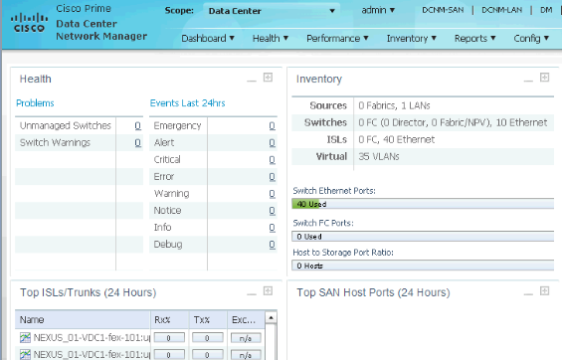

Cisco Prime™ Data Center Network Manager (DCNM) dá suporte ao conceito de Unified Fabric combinando gerenciamento de ambas as redes Ethernet e as redes de armazenamentos (SAN) em um único painel (dashboard).

Este painel de gerenciamento permite que administradores de sistemas de armazenamento diagnosticar problemas e verificar performance através de toda a linha de plataforma Cisco NX-OS, incluindo Cisco Nexus® e família Cisco MDS 9000.

Cisco DCNM prove um framework robusto e uma grande gama de funcionalidades que atende roteamento, comutação (switching) e sistemas de armazenamento que os administradores precisam no presente e no futuro de centro de dados com sistemas de virtualização. Cisco Prime DCNM oferece visibilidade a hosts virtualizados integrando usando padrões de indústria a Hypervisors e prove mapeamento por capacidade de hosts, gerenciando de forma fácil e diagnosticando problemas em servidores físicos e virtuais. Cisco DCNM prove linhas de provisionamento dos recursos de Unified Fabric e monitoramento proativo de componentes de LAN e SAN.

O software foi instalado no servidor PREVI34, o mesmo atendeu a todas as necessidades de requisitos informados pelo fabricante.

O acesso ao gerenciamento da solução DCNM deve ser feito a partir da seguinte URL:

<https://previ34>

Nota: O acesso deve ser feito somente através de https na porta 443, o sistema não executa na porta http (80).

A seguir segue a tela com o painel inicial. Nela é possível ter um resumo dos equipamentos monitorados, alertas e principais utilizações por interfaces.

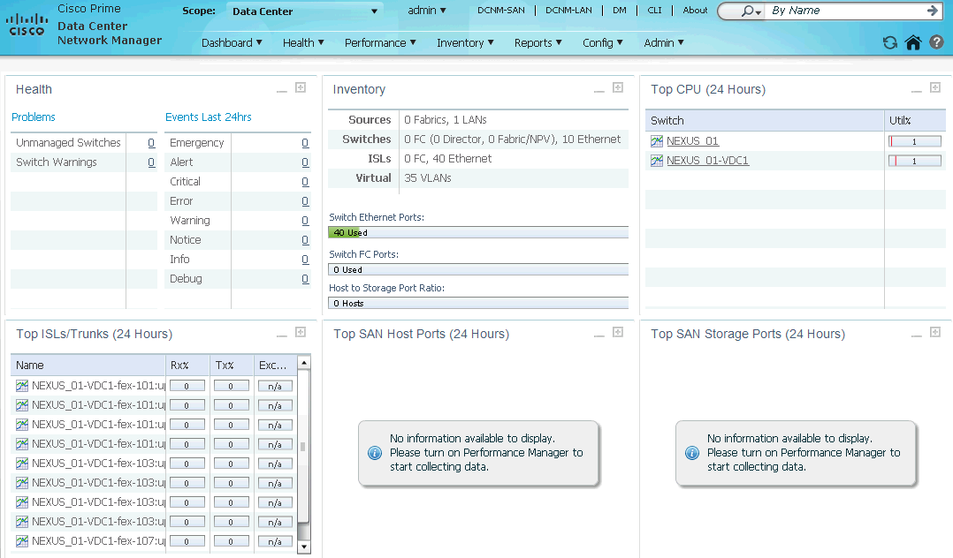

Na tela a seguir é possível listar o inventário de switches.

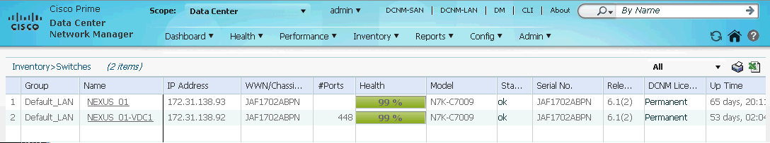

Na tela a seguir é possível realizar a ligação lógica de cada chassi, logs de eventos e tráfego do mesmo.

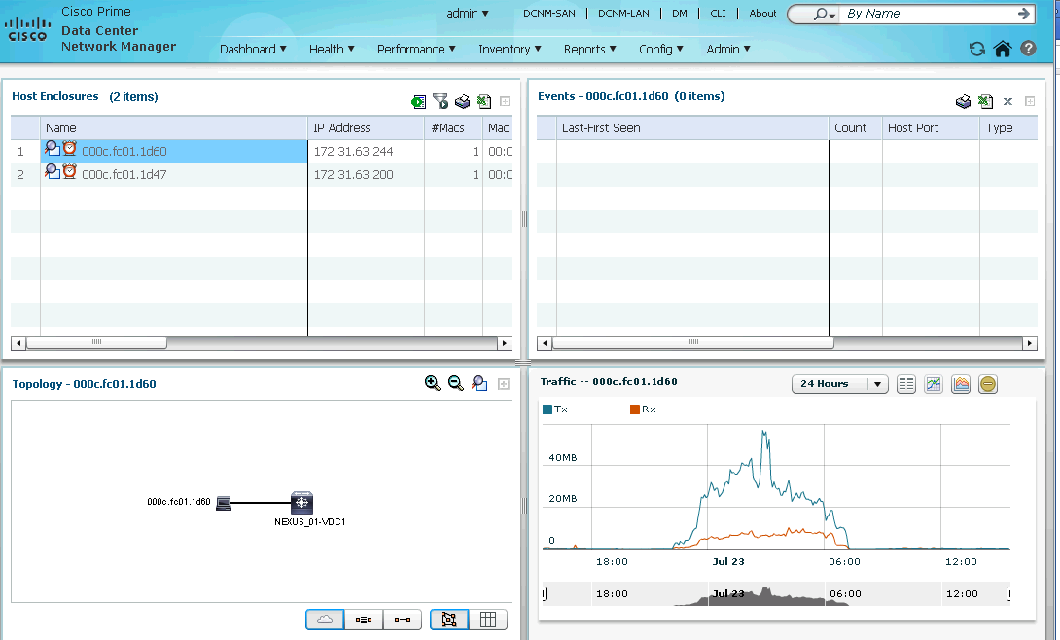

O sistema possui registro de todas as atividades realizadas na plataforma, estes registros podem ser acessados através do menu Health->Accounting.

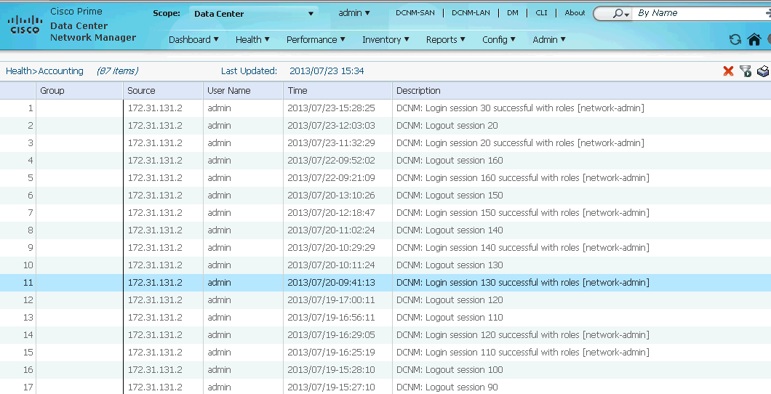

De acordo com o estado dos equipamentos é possível monitora-lo e analisar os últimos eventos ocorridos através do menu Health->Events.

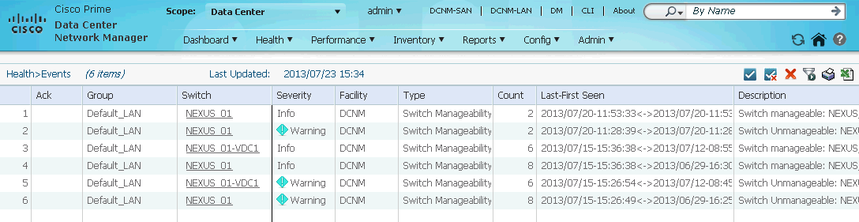

Uma das informações mais importantes a serem coletadas sobre os trunks são os dados de tráfego passante e contadores de erros. Estes podem ser facilmente analisados através da tela abaixo, a mesma pode ser acessada através do menu Performance->ISL Traffic and Errors.

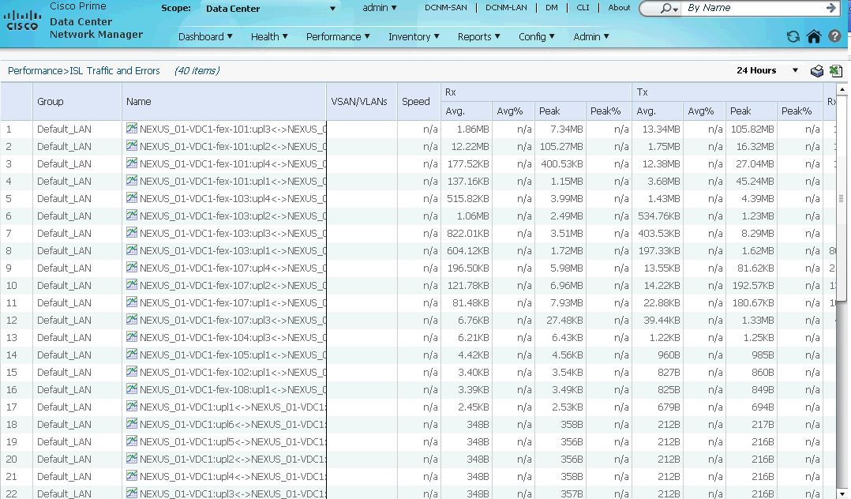

Adicionalmente além do inventário de cada switch, também é possível inventariar cada módulo existente na solução, como cada cartão Fabric ou até mesmo cada módulo de ventoinha instalados. Estas informações podem ser obtidas através do menu Inventory->Modules.

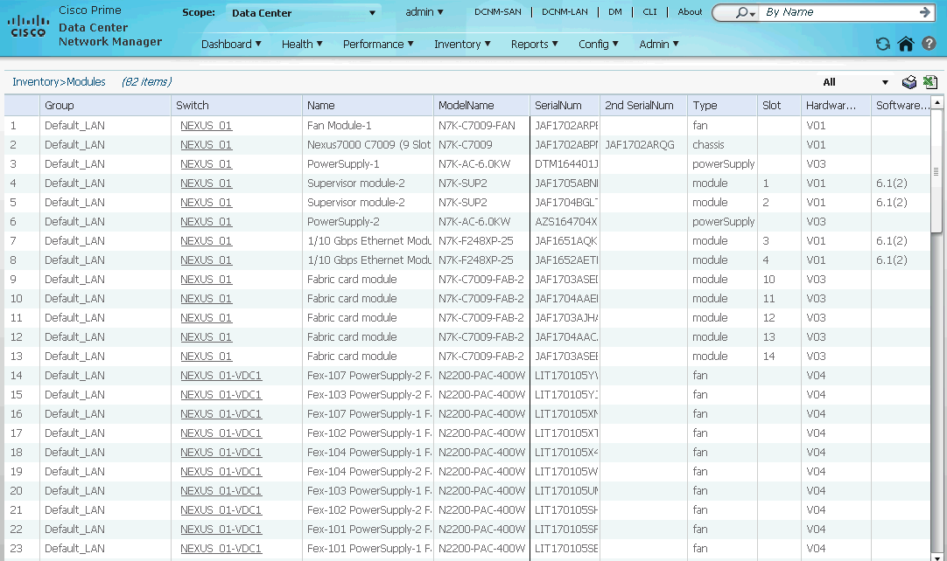

Todas estas informações são acessíveis graças a uma configuração prévia onde foram cadastrados os switches virtuais existentes como origens destas coletas, para analisar estas configurações utilize o menu Admin->Data Sources->LAN.

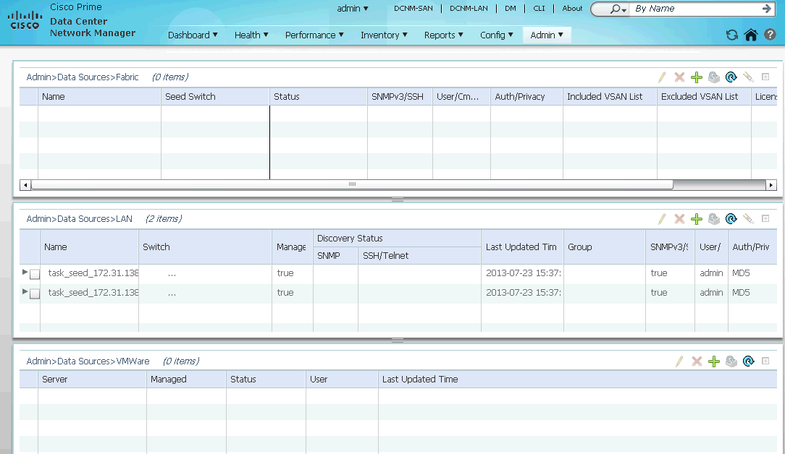

# Backup da configuração

## NEXUS_01

!Command: show running-config

!Time: Tue Jul 23 17:35:40 2013

version 6.1(2)

hostname NEXUS_01

system admin-vdc

install feature-set fex

vdc NEXUS_01 id 1

cpu-share 5

limit-resource vlan minimum 16 maximum 4094

limit-resource monitor-session minimum 0 maximum 2

limit-resource monitor-session-erspan-dst minimum 0 maximum 23

limit-resource vrf minimum 2 maximum 4096

limit-resource port-channel minimum 0 maximum 768

limit-resource u4route-mem minimum 96 maximum 96

limit-resource u6route-mem minimum 24 maximum 24

limit-resource m4route-mem minimum 58 maximum 58

limit-resource m6route-mem minimum 8 maximum 8

limit-resource monitor-session-inband-src minimum 0 maximum 1

vdc VDC1 id 2

limit-resource module-type f2

allow feature-set fex

cpu-share 5

allocate interface Ethernet3/1-48

allocate interface Ethernet4/1-48

boot-order 1

limit-resource vlan minimum 16 maximum 4094

limit-resource monitor-session minimum 0 maximum 2

limit-resource monitor-session-erspan-dst minimum 0 maximum 23

limit-resource vrf minimum 2 maximum 4096

limit-resource port-channel minimum 0 maximum 768

limit-resource u4route-mem minimum 8 maximum 8

limit-resource u6route-mem minimum 4 maximum 4

limit-resource m4route-mem minimum 8 maximum 8

limit-resource m6route-mem minimum 5 maximum 5

limit-resource monitor-session-inband-src minimum 0 maximum 1

feature telnet

clock protocol ntp vdc 2

username admin password 5 $1$dEuxKjpq$xr9Yxk/bFMANXqCIF0p061 role network-admin

username tensistemas password 5 $1$NrpEkSnN$RX/u3GUhZLkMFxXDcgWbn. role network-operator

ip domain-lookup

system default switchport

copp profile strict

snmp-server user admin network-admin auth md5 0xb6c747bd0e9347d0bc707521ea7f2103 priv 0xb6c747bd0e9347d0bc707521ea7f2103 localizedkey

snmp-server user tensistemas network-operator auth md5 0x09cd00c7e4994de9230de557f89bec7b priv 0x09cd00c7e4994de9230de557f89bec7b localizedkey

rmon event 1 log trap public description FATAL(1) owner PMON@FATAL

rmon event 2 log trap public description CRITICAL(2) owner PMON@CRITICAL

rmon event 3 log trap public description ERROR(3) owner PMON@ERROR

rmon event 4 log trap public description WARNING(4) owner PMON@WARNING

rmon event 5 log trap public description INFORMATION(5) owner PMON@INFO

ntp server 172.31.128.240

ntp server 172.31.128.251 prefer

ntp logging

vrf context management

ip route 0.0.0.0/0 172.31.138.254

vlan 1

interface mgmt0

ip address 172.31.138.93/24

clock timezone BRT -3 0

line console

line vty

exec-timeout 120

boot kickstart bootflash:/n7000-s2-kickstart.6.1.2.bin sup-1

boot system bootflash:/n7000-s2-dk9.6.1.2.bin sup-1

boot kickstart bootflash:/n7000-s2-kickstart.6.1.2.bin sup-2

boot system bootflash:/n7000-s2-dk9.6.1.2.bin sup-2

## NEXUS_01-VDC1:

NEXUS_01-VDC1# sh running-config

!Command: show running-config

!Time: Tue Jul 23 13:16:54 2013

version 6.1(2)

feature-set fex

hostname VDC1

cfs eth distribute

feature interface-vlan

feature lacp

feature dhcp

feature vpc

feature vtp

feature sla sender

feature sla responder

username admin password 5 $1$TlCZweVU$ZRK7/wVqzG.q.KWeqM64e0 role vdc-admin

username tensistemas password 5 $1$aZ7b/OVn$nupYBXFhLzhAJEE9NVPhT. role vdc-operator

username tensistemas role vdc-admin

ip domain-lookup

ip name-server 172.31.63.6

ip access-list acl_bloomberg

10 permit udp any any eq bootpc

20 permit udp any any eq bootps

30 permit ip 172.30.255.0/24 208.134.161.0/24

40 permit ip 172.30.255.0/24 205.183.246.0/24

50 permit ip 172.30.255.0/24 199.105.176.0/21

60 permit ip 172.30.255.0/24 199.105.184.0/23

70 permit ip 172.30.255.0/24 69.184.0.0/16

80 deny ip any any log

ip access-list acl_bm&f

10 permit udp any any eq bootpc

20 permit udp any any eq bootps

30 permit ip 172.31.135.0/24 114.255.0.0/16

40 permit ip 172.31.135.0/24 115.0.0.0/8

50 deny ip any any log

ip access-list acl_vlan_secti

10 permit ip 172.31.140.0/24 172.31.32.0/19

20 permit ip 172.31.140.0/24 172.31.128.0/24

30 permit tcp 172.31.140.0/24 172.31.128.250/32 eq 3128

40 permit tcp 172.31.140.0/24 172.31.32.3/32 eq 3389

50 permit tcp 172.31.140.0/24 172.31.63.221/32 eq domain

60 permit tcp 172.31.140.0/24 172.31.63.73/32 eq domain

70 permit udp 172.31.140.0/24 172.31.63.221/32 eq domain

80 permit udp 172.31.140.0/24 172.31.63.73/32 eq domain

90 permit tcp any any established

100 deny ip any any log

ip access-list acl_vlan_seguranca_in

10 permit ip 172.31.131.0/24 any

20 deny ip any any log

ip access-list acl_vlan_seguranca_out

10 permit tcp 172.31.128.0/24 172.31.131.0/24 eq 6025

20 permit tcp 172.31.32.0/19 172.31.131.0/24 eq 3389

30 permit tcp 172.31.32.0/19 172.31.131.0/24 eq 13782

40 permit tcp 172.31.32.0/19 172.31.131.0/24 eq cmd

50 permit tcp 172.31.32.0/19 172.31.131.0/24 eq 13720

60 permit tcp 172.31.32.0/19 172.31.131.0/24 eq 13721

70 permit tcp 172.31.32.0/19 172.31.131.0/24 eq 13722

80 permit tcp 172.31.32.0/19 172.31.131.0/24 eq 13723

90 permit tcp 172.31.32.0/19 172.31.131.0/24 eq 13724

100 permit tcp 192.168.121.249/32 172.31.131.7/32 eq 257

110 permit tcp 172.31.130.1/32 172.31.131.7/32 eq 257

120 permit tcp 172.31.130.2/32 172.31.131.7/32 eq 257

130 permit tcp 172.31.32.0/19 172.31.131.0/24 eq 13783

140 permit tcp 172.31.32.0/19 172.31.131.0/24 eq 10050

150 permit udp any 172.31.131.0/24

160 permit icmp any 172.31.131.0/24

170 permit tcp any any established

180 deny ip any any log

fex 101

pinning max-links 1

description "RACK-01"

serial SSI164609DV

fex 102

pinning max-links 1

description "FEX0102"

fex 103

pinning max-links 1

description "FEX0103"

fex 104

pinning max-links 1

description "FEX0104"

fex 105

pinning max-links 1

description "FEX0105"

fex 106

pinning max-links 1

description "FEX0106"

fex 107

pinning max-links 1

description "FEX0107"

fex 108

pinning max-links 1

description "FEX0108"

snmp-server contact Elizeu

snmp-server location Sala Cofre

snmp-server source-interface inform Vlan170

snmp-server user admin vdc-admin auth md5 0xf463dc2b63dc62513f498a4f5f62207e priv 0xf463dc2b63dc62513f498a4f5f62207e localizedkey

snmp-server user tensistemas vdc-operator auth md5 0x53b0250806aaadd7223847655326e767 priv 0x53b0250806aaadd7223847655326e767 localizedkey

snmp-server user tensistemas vdc-admin

rmon event 1 log trap public description FATAL(1) owner PMON@FATAL

rmon event 2 log trap public description CRITICAL(2) owner PMON@CRITICAL

rmon event 3 log trap public description ERROR(3) owner PMON@ERROR

rmon event 4 log trap public description WARNING(4) owner PMON@WARNING

rmon event 5 log trap public description INFORMATION(5) owner PMON@INFO

snmp-server community master group vdc-operator

ntp server 172.31.128.240

ntp server 172.31.128.251 prefer

ntp logging

ntp master 3

ip route 0.0.0.0/0 172.31.130.254

ip route 10.1.1.1/32 Null0

ip route 10.1.1.2/32 Null0

ip route 63.240.63.69/32 Null0

ip route 169.254.0.0/16 Null0

ip route 192.168.22.174/32 192.168.5.54

ip route 192.168.23.1/32 Null0

ip route 192.168.35.1/32 Null0

ip route 192.168.52.1/32 Null0

ip route 192.168.67.1/32 Null0

ip route 192.168.71.1/32 Null0

ip route 192.168.106.1/32 Null0

ip route 192.168.117.1/32 Null0

ip route 192.168.152.1/32 Null0

ip route 192.168.153.1/32 Null0

ip route 192.168.182.1/32 Null0

ip route 192.168.186.1/32 Null0

ip route 192.168.206.1/32 Null0

ip route 192.168.213.1/32 Null0

ip route 192.168.222.1/32 Null0

ip route 192.168.254.1/32 Null0

vrf context management

service dhcp

ip dhcp relay

interface Vlan1

interface Vlan70

ip address 192.168.5.51/29

description *** UPLINK P/PREVI-ROUTER2 - PRISMA ***

no shutdown

interface Vlan80

ip address 172.31.255.254/19

ip dhcp relay address 172.31.62.172

ip dhcp relay address 172.31.63.248

description *** EXTERNOS - PENDENTE DE UTILIZACAO ***

no shutdown

interface Vlan110

ip access-group acl_bloomberg in

ip address 172.30.255.254/24

ip dhcp relay address 172.31.62.172

ip dhcp relay address 172.31.63.248

description *** Bloomberg ***

no shutdown

interface Vlan115

ip access-group acl_bm&f in

ip address 172.31.135.254/24

ip dhcp relay address 172.31.62.172

ip dhcp relay address 172.31.63.248

description *** BM&F ***

no shutdown

interface Vlan140

ip address 172.31.130.253/24

description *** SW01-Checkpoint ***

no shutdown

interface Vlan150

ip access-group acl_vlan_seguranca_in in

ip access-group acl_vlan_seguranca_out out

ip address 172.31.131.254/24

description *** Seguranca ***

no shutdown

interface Vlan155

ip address 172.31.143.254/24

ip dhcp relay address 172.31.62.172

ip dhcp relay address 172.31.63.248

description *** AD-VDI-contingencia ***

no shutdown

interface Vlan160

no ip redirects

ip address 172.31.63.254/19

ip address 172.31.63.2/19 secondary

ip dhcp relay address 172.31.62.172

ip dhcp relay address 172.31.63.248

description *** Servidores ***

no shutdown

interface Vlan170

no ip redirects

ip address 172.31.138.254/24

ip address 172.31.138.92/24 secondary

description *** Gerencia ***

no shutdown

interface Vlan180

ip address 172.31.139.254/24

ip dhcp relay address 172.31.62.172

ip dhcp relay address 172.31.63.248

description Telefonia-IP

no shutdown

interface Vlan190

ip access-group acl_vlan_secti in

description *** Hardening - rede isolada-nao habilitar ***

interface Vlan200

ip address 172.31.141.254/24

ip dhcp relay address 172.31.62.172

ip dhcp relay address 172.31.63.248

description *** Desktop-Virtual ***

no shutdown

interface Vlan205

ip address 172.31.142.254/24

ip dhcp relay address 172.31.62.172

ip dhcp relay address 172.31.63.248

description *** Impress.Corporativas ***

no shutdown

interface Vlan210

ip address 172.31.64.254/24

ip dhcp relay address 172.31.62.172

ip dhcp relay address 172.31.63.248

description *** SW17 ***

no shutdown

interface Vlan215

ip address 172.31.65.254/24

ip dhcp relay address 172.31.62.172

ip dhcp relay address 172.31.63.248

description *** SW06 ***

no shutdown

interface Vlan220

ip address 172.31.66.254/24

ip dhcp relay address 172.31.62.172

ip dhcp relay address 172.31.63.248

description *** SW02-A ***

no shutdown

interface Vlan225

ip address 172.31.67.254/24

ip dhcp relay address 172.31.62.172

ip dhcp relay address 172.31.63.248

description *** SW02-B ***

no shutdown

interface Vlan230

ip address 172.31.68.254/24

ip dhcp relay address 172.31.62.172

ip dhcp relay address 172.31.63.248

description *** SW03-A ***

no shutdown

interface Vlan235

ip address 172.31.69.254/24

ip dhcp relay address 172.31.62.172

ip dhcp relay address 172.31.63.248

description *** SW03-B ***

no shutdown

interface Vlan240

ip address 172.31.70.254/24

ip dhcp relay address 172.31.62.172

ip dhcp relay address 172.31.63.248

description *** SW04-A ***

no shutdown

interface Vlan245

ip address 172.31.71.254/24

ip dhcp relay address 172.31.62.172

ip dhcp relay address 172.31.63.248

description *** SW04-B ***

no shutdown

interface Vlan250

ip address 172.31.72.254/24

ip dhcp relay address 172.31.62.172

ip dhcp relay address 172.31.63.248

description *** SW05-A ***

no shutdown

interface Vlan255

ip address 172.31.73.254/24

ip dhcp relay address 172.31.62.172

ip dhcp relay address 172.31.63.248

description *** SW05-B ***

no shutdown

interface Vlan260

ip address 172.31.74.254/24

ip dhcp relay address 172.31.62.172

ip dhcp relay address 172.31.63.248

description *** SW16-A ***

no shutdown

interface Vlan265

ip address 172.31.75.254/24

ip dhcp relay address 172.31.62.172

ip dhcp relay address 172.31.63.248

description *** SW16-B ***

no shutdown

interface Vlan270

ip address 172.31.76.254/24

ip dhcp relay address 172.31.62.172

ip dhcp relay address 172.31.63.248

description *** SW37-A ***

no shutdown

interface Vlan275

ip address 172.31.77.254/24

ip dhcp relay address 172.31.62.172

ip dhcp relay address 172.31.63.248

description *** SW37-B ***

no shutdown

interface port-channel1

description ETHERCHANNEL COM SWITCH_01

switchport

switchport mode trunk

switchport trunk native vlan 160

interface port-channel17

description LACP com PREVI17

switchport

switchport access vlan 160

spanning-tree port type edge

flowcontrol send on

interface port-channel24

description ETHERCHANNEL COM SWITCH_38

switchport

switchport mode trunk

switchport trunk native vlan 160

switchport trunk allowed vlan 155,160,170,190,200

interface port-channel25

description ETHERCHANNEL COM SWITCH_25

switchport

switchport mode trunk

switchport trunk native vlan 160

switchport trunk allowed vlan 155,160,170,190,200

interface port-channel34

description LACP com PREVI34

switchport

switchport access vlan 150

spanning-tree port type edge

flowcontrol send on

interface port-channel38

description ETHERCHANNEL COM SWITCH_38

switchport

switchport mode trunk

switchport trunk native vlan 160

switchport trunk allowed vlan 155,160,170,190,200

interface port-channel101

switchport

switchport mode fex-fabric

fex associate 101

interface port-channel102

switchport

switchport mode fex-fabric

fex associate 102

interface port-channel103

switchport

switchport mode fex-fabric

fex associate 103

interface port-channel104

switchport

switchport mode fex-fabric

fex associate 104

interface port-channel105

switchport

switchport mode fex-fabric

fex associate 105

interface port-channel106

switchport

switchport mode fex-fabric

fex associate 106

interface port-channel107

switchport

switchport mode fex-fabric

fex associate 107

interface port-channel108

switchport

switchport mode fex-fabric

fex associate 108

interface Ethernet3/1

switchport

switchport mode fex-fabric

fex associate 101

channel-group 101

no shutdown

interface Ethernet3/2

switchport

switchport mode fex-fabric

fex associate 101

channel-group 101

no shutdown

interface Ethernet3/3

switchport

switchport mode fex-fabric

fex associate 102

channel-group 102

no shutdown

interface Ethernet3/4

switchport

switchport mode fex-fabric

fex associate 102

channel-group 102

no shutdown

interface Ethernet3/5

switchport

switchport mode fex-fabric

fex associate 105

channel-group 105

no shutdown

interface Ethernet3/6

switchport

switchport mode fex-fabric

fex associate 105

channel-group 105

no shutdown

interface Ethernet3/7

description TRUNK COM SWITCH_25

switchport

switchport mode trunk

switchport trunk native vlan 160

switchport trunk allowed vlan 155,160,170,190,200

channel-group 25

no shutdown

interface Ethernet3/8

description TRUNK COM SWITCH_25

switchport

switchport mode trunk

switchport trunk native vlan 160

switchport trunk allowed vlan 155,160,170,190,200

channel-group 25

no shutdown

interface Ethernet3/9

switchport

switchport mode fex-fabric

fex associate 106

channel-group 106

no shutdown

interface Ethernet3/10

switchport

switchport mode fex-fabric

fex associate 106

channel-group 106

no shutdown

interface Ethernet3/11

description TRUNK COM SWITCH_38

switchport

switchport mode trunk

switchport trunk native vlan 160

switchport trunk allowed vlan 155,160,170,190,200

channel-group 38

no shutdown

interface Ethernet3/12

description TRUNK COM SWITCH_38

switchport

switchport mode trunk

switchport trunk native vlan 160

switchport trunk allowed vlan 155,160,170,190,200

channel-group 38

no shutdown

interface Ethernet3/13

switchport

switchport mode fex-fabric

fex associate 103

channel-group 103

no shutdown

interface Ethernet3/14

switchport

switchport mode fex-fabric

fex associate 103

channel-group 103

no shutdown

interface Ethernet3/15

switchport

switchport mode fex-fabric

fex associate 104

channel-group 104

no shutdown

interface Ethernet3/16

switchport

switchport mode fex-fabric

fex associate 104

channel-group 104

no shutdown

interface Ethernet3/17

switchport

switchport mode fex-fabric

fex associate 107

channel-group 107

no shutdown

interface Ethernet3/18

switchport

switchport mode fex-fabric

fex associate 107

channel-group 107

no shutdown

interface Ethernet3/19

switchport

switchport mode fex-fabric

fex associate 108

channel-group 108

no shutdown

interface Ethernet3/20

switchport

switchport mode fex-fabric

fex associate 108

channel-group 108

no shutdown

interface Ethernet3/21

switchport

switchport mode fex-fabric

fex associate 105

channel-group 105

no shutdown

interface Ethernet3/22

switchport

switchport mode fex-fabric

fex associate 105

channel-group 105

no shutdown

interface Ethernet3/23

interface Ethernet3/24

interface Ethernet3/25

description TRUNK C/ 6500

switchport

switchport mode trunk

switchport trunk native vlan 160

channel-group 1

no shutdown

interface Ethernet3/26

description TRUNK C/ 6500

switchport

switchport mode trunk

switchport trunk native vlan 160

channel-group 1

no shutdown

interface Ethernet3/27

description TRUNK C/ 6500

switchport

switchport mode trunk

switchport trunk native vlan 160

channel-group 1

no shutdown

interface Ethernet3/28

description TRUNK C/ 6500

switchport

switchport mode trunk

switchport trunk native vlan 160

channel-group 1

no shutdown

interface Ethernet3/29

description PREVI05

switchport

switchport access vlan 160

spanning-tree port type edge

no shutdown

interface Ethernet3/30

interface Ethernet3/31

interface Ethernet3/32

interface Ethernet3/33

switchport

switchport mode fex-fabric

fex associate 106

channel-group 106

no shutdown

interface Ethernet3/34

switchport

switchport mode fex-fabric

fex associate 106

channel-group 106

no shutdown

interface Ethernet3/35

interface Ethernet3/36

interface Ethernet3/37

interface Ethernet3/38

interface Ethernet3/39

interface Ethernet3/40

interface Ethernet3/41

interface Ethernet3/42

interface Ethernet3/43

interface Ethernet3/44

interface Ethernet3/45

interface Ethernet3/46

interface Ethernet3/47

interface Ethernet3/48

interface Ethernet4/1

switchport

switchport mode fex-fabric

fex associate 101

channel-group 101

no shutdown

interface Ethernet4/2

switchport

switchport mode fex-fabric

fex associate 101

channel-group 101

no shutdown

interface Ethernet4/3

switchport

switchport mode fex-fabric

fex associate 102

channel-group 102

no shutdown

interface Ethernet4/4

switchport

switchport mode fex-fabric

fex associate 102

channel-group 102

no shutdown

interface Ethernet4/5

switchport

switchport mode fex-fabric

fex associate 105

channel-group 105

no shutdown

interface Ethernet4/6

switchport

switchport mode fex-fabric

fex associate 105

channel-group 105

no shutdown

interface Ethernet4/7

description TRUNK COM SWITCH_25

switchport

switchport mode trunk

switchport trunk native vlan 160

switchport trunk allowed vlan 155,160,170,190,200

channel-group 25

no shutdown

interface Ethernet4/8

description TRUNK COM SWITCH_25

switchport

switchport mode trunk

switchport trunk native vlan 160

switchport trunk allowed vlan 155,160,170,190,200

channel-group 25

no shutdown

interface Ethernet4/9

switchport

switchport mode fex-fabric

fex associate 106

channel-group 106

no shutdown

interface Ethernet4/10

switchport

switchport mode fex-fabric

fex associate 106

channel-group 106

no shutdown

interface Ethernet4/11

description TRUNK COM SWITCH_38

switchport

switchport mode trunk

switchport trunk native vlan 160

switchport trunk allowed vlan 155,160,170,190,200

channel-group 38

no shutdown

interface Ethernet4/12

description TRUNK COM SWITCH_38

switchport

switchport mode trunk

switchport trunk native vlan 160

switchport trunk allowed vlan 155,160,170,190,200

channel-group 38

no shutdown

interface Ethernet4/13

switchport

switchport mode fex-fabric

fex associate 103

channel-group 103

no shutdown

interface Ethernet4/14

switchport

switchport mode fex-fabric

fex associate 103

channel-group 103

no shutdown

interface Ethernet4/15

switchport

switchport mode fex-fabric

fex associate 104

channel-group 104

no shutdown

interface Ethernet4/16

switchport

switchport mode fex-fabric

fex associate 104

channel-group 104

no shutdown

interface Ethernet4/17

switchport

switchport mode fex-fabric

fex associate 107

channel-group 107

no shutdown

interface Ethernet4/18

switchport

switchport mode fex-fabric

fex associate 107

channel-group 107

no shutdown

interface Ethernet4/19

switchport

switchport mode fex-fabric

fex associate 108

channel-group 108

no shutdown

interface Ethernet4/20

switchport

switchport mode fex-fabric

fex associate 108

channel-group 108

no shutdown

interface Ethernet4/21

switchport

switchport mode fex-fabric

fex associate 105

channel-group 105

no shutdown

interface Ethernet4/22

switchport

switchport mode fex-fabric

fex associate 105

channel-group 105

no shutdown

interface Ethernet4/23

interface Ethernet4/24

interface Ethernet4/25

description TRUNK C/ 6500

switchport

switchport mode trunk

switchport trunk native vlan 160

channel-group 1

no shutdown

interface Ethernet4/26

description TRUNK C/ 6500

switchport

switchport mode trunk

switchport trunk native vlan 160

channel-group 1

no shutdown

interface Ethernet4/27

description TRUNK C/ 6500

switchport

switchport mode trunk

switchport trunk native vlan 160

channel-group 1

no shutdown

interface Ethernet4/28

description TRUNK C/ 6500

switchport

switchport mode trunk

switchport trunk native vlan 160

channel-group 1

no shutdown

interface Ethernet4/29

description PREVI12

switchport

switchport access vlan 160

spanning-tree port type edge

no shutdown

interface Ethernet4/30

interface Ethernet4/31

interface Ethernet4/32

interface Ethernet4/33

switchport

switchport mode fex-fabric

fex associate 106

channel-group 106

no shutdown

interface Ethernet4/34

switchport

switchport mode fex-fabric

fex associate 106

channel-group 106

no shutdown

interface Ethernet4/35

interface Ethernet4/36

interface Ethernet4/37

interface Ethernet4/38

interface Ethernet4/39

interface Ethernet4/40

interface Ethernet4/41

interface Ethernet4/42

interface Ethernet4/43

interface Ethernet4/44

interface Ethernet4/45

interface Ethernet4/46

interface Ethernet4/47

interface Ethernet4/48

interface Ethernet101/1/1

description PREVI34

switchport

switchport access vlan 150

spanning-tree port type edge

channel-group 34

no shutdown

interface Ethernet101/1/2

description PREVI110 VOT WEB

switchport

switchport access vlan 160

no shutdown

interface Ethernet101/1/3

description PREVI111 VOT WEB

switchport

switchport access vlan 160

no shutdown

interface Ethernet101/1/4

description PREVI79_G058

switchport

switchport access vlan 160

no shutdown

interface Ethernet101/1/5

description PREVI67

switchport

switchport access vlan 160

no shutdown

interface Ethernet101/1/6

description PREVI69T

switchport

switchport access vlan 160

no shutdown

interface Ethernet101/1/7

description PREVI73-G033-2

switchport

switchport access vlan 160

no shutdown

interface Ethernet101/1/8

description PREVI73-G034-2 backup

switchport

switchport access vlan 6

no shutdown

interface Ethernet101/1/9

description PREVI73 MGR

switchport

switchport access vlan 160

no shutdown

interface Ethernet101/1/10

description PREVI35 INTRANET

switchport

switchport access vlan 160

no shutdown

interface Ethernet101/1/11

description PREVI34 LACP

switchport

switchport access vlan 150

spanning-tree port type edge

channel-group 34

no shutdown

interface Ethernet101/1/12

description PREVI79

switchport

switchport access vlan 160

spanning-tree port type edge

no shutdown

interface Ethernet101/1/13

description PREVI80_G067

switchport

switchport access vlan 160

spanning-tree port type edge

no shutdown

interface Ethernet101/1/14

description NETBACKUP - BKP

switchport

switchport access vlan 6

spanning-tree port type edge

no shutdown

interface Ethernet101/1/15

description PREVI79-Gerencia

switchport

switchport access vlan 160

spanning-tree port type edge

no shutdown

interface Ethernet101/1/16

description PREVI80_G065

switchport

switchport access vlan 160

spanning-tree port type edge

no shutdown

interface Ethernet101/1/17

description PREVI41 DW NOVA

switchport

switchport access vlan 160

spanning-tree port type edge

no shutdown

interface Ethernet101/1/18

description PREVI41-DW-G050-CONSOLE

switchport

switchport access vlan 160

no shutdown

interface Ethernet101/1/19

description PREVI80-Gerencia

switchport

switchport access vlan 160

spanning-tree port type edge

no shutdown

interface Ethernet101/1/20

description PREVI05-N-PORTA2-BACKUP

switchport

switchport access vlan 6

spanning-tree port type edge

speed 1000

duplex full

no shutdown

interface Ethernet101/1/21

description PREVI12-N-PORTA2-BACKUP

switchport

switchport access vlan 6

spanning-tree port type edge

speed 1000

duplex full

no shutdown

interface Ethernet101/1/22

description PREVI12-N-PORTA1 - NAO IDENTIFICADA NO SERVIDOR

switchport

switchport access vlan 160

spanning-tree port type edge

no shutdown

interface Ethernet101/1/23

description PREVI41_G167_backup

switchport

switchport access vlan 6

spanning-tree port type edge

no shutdown

interface Ethernet101/1/24

description PREVI17 - LACP

switchport

switchport access vlan 160

spanning-tree port type edge

channel-group 17

no shutdown

interface Ethernet101/1/25

description PREVI17 - LACP

switchport

switchport access vlan 160

spanning-tree port type edge

channel-group 17

no shutdown

interface Ethernet101/1/26

description CFTV

switchport

switchport access vlan 160

spanning-tree port type edge

no shutdown

interface Ethernet101/1/27

description CFTV

switchport

switchport access vlan 160

spanning-tree port type edge

no shutdown

interface Ethernet101/1/28

description ROBOT STORAGETEK

switchport

switchport access vlan 160

spanning-tree port type edge

no shutdown

interface Ethernet101/1/29

description SWITCH_BROCADE_1-ROBO

switchport

switchport access vlan 160

spanning-tree port type edge

no shutdown

interface Ethernet101/1/30

description SWITCH_BROCADE_2-ROBO

switchport

switchport access vlan 160

spanning-tree port type edge

no shutdown

interface Ethernet101/1/31

description SWITCH_BROCADE_12-VNX

switchport

switchport access vlan 160

spanning-tree port type edge

no shutdown

interface Ethernet101/1/32

description VNX-SPA

switchport

switchport access vlan 160

spanning-tree port type edge

no shutdown

interface Ethernet101/1/33

description VNX-SPB

switchport

switchport access vlan 160

spanning-tree port type edge

no shutdown

interface Ethernet101/1/34

description RPA1

switchport

switchport access vlan 170

spanning-tree port type edge

no shutdown

interface Ethernet101/1/35

description RPA2

switchport

switchport access vlan 170

spanning-tree port type edge

no shutdown

interface Ethernet101/1/36

description SWITCH_BROCADE_11-VNX

switchport

switchport access vlan 160

spanning-tree port type edge

no shutdown

interface Ethernet101/1/37

description BLADE01_ILO_A

switchport

switchport access vlan 170

spanning-tree port type edge

no shutdown

interface Ethernet101/1/38

description BLADE01_ILO_B

switchport

switchport access vlan 170

spanning-tree port type edge

no shutdown

interface Ethernet101/1/39

description BLADE02_OA

switchport

switchport access vlan 170

spanning-tree port type edge

speed 100

duplex full

no shutdown

interface Ethernet101/1/40

interface Ethernet101/1/41

interface Ethernet101/1/42

interface Ethernet101/1/43

interface Ethernet101/1/44

interface Ethernet101/1/45

interface Ethernet101/1/46

interface Ethernet101/1/47

interface Ethernet101/1/48

interface Ethernet102/1/1

interface Ethernet102/1/2

interface Ethernet102/1/3

interface Ethernet102/1/4

interface Ethernet102/1/5

interface Ethernet102/1/6

interface Ethernet102/1/7

interface Ethernet102/1/8

interface Ethernet102/1/9

interface Ethernet102/1/10

interface Ethernet102/1/11

interface Ethernet102/1/12

interface Ethernet102/1/13

interface Ethernet102/1/14

interface Ethernet102/1/15

interface Ethernet102/1/16

interface Ethernet102/1/17

interface Ethernet102/1/18

interface Ethernet102/1/19

interface Ethernet102/1/20

interface Ethernet102/1/21

interface Ethernet102/1/22

interface Ethernet102/1/23

interface Ethernet102/1/24

interface Ethernet102/1/25

interface Ethernet102/1/26

interface Ethernet102/1/27

interface Ethernet102/1/28

interface Ethernet102/1/29

interface Ethernet102/1/30

interface Ethernet102/1/31

interface Ethernet102/1/32

interface Ethernet102/1/33

interface Ethernet102/1/34

interface Ethernet102/1/35

interface Ethernet102/1/36

interface Ethernet102/1/37

interface Ethernet102/1/38

interface Ethernet102/1/39

interface Ethernet102/1/40

interface Ethernet102/1/41

interface Ethernet102/1/42

interface Ethernet102/1/43

interface Ethernet102/1/44

interface Ethernet102/1/45

interface Ethernet102/1/46

interface Ethernet102/1/47

interface Ethernet102/1/48

interface Ethernet103/1/1

description PREVI32 OEM DSV

switchport

switchport access vlan 160

spanning-tree port type edge

no shutdown

interface Ethernet103/1/2

description PREVI11 VOTACAO

switchport

switchport access vlan 160

spanning-tree port type edge

no shutdown

interface Ethernet103/1/3

description PREVI34 CSCWRKS VMS

switchport

switchport access vlan 150

spanning-tree port type edge

no shutdown

interface Ethernet103/1/4

description PREVI30 ETL DSV

switchport

switchport access vlan 160

spanning-tree port type edge

no shutdown

interface Ethernet103/1/5

description PREVI69 RVS

switchport

switchport access vlan 160

spanning-tree port type edge

no shutdown

interface Ethernet103/1/6

description PREVI21 CSCWRKS NEW

switchport

switchport access vlan 160

spanning-tree port type edge

no shutdown

interface Ethernet103/1/7

description PREVI89 - SMARTCENTER

switchport

switchport access vlan 150

spanning-tree port type edge

no shutdown

interface Ethernet103/1/8

description GERENCIA ID 2

switchport

switchport access vlan 160

spanning-tree port type edge

no shutdown

interface Ethernet103/1/9

description IDS CISCO 4215

switchport

switchport access vlan 150

spanning-tree port type edge

no shutdown

interface Ethernet103/1/10

description GERENCIA IRONPORT

switchport

switchport access vlan 150

spanning-tree port type edge

no shutdown

interface Ethernet103/1/11

description PREVI87

switchport

switchport access vlan 160

spanning-tree port type edge

no shutdown

interface Ethernet103/1/12

description PREVI65

switchport

switchport access vlan 160

spanning-tree port type edge

no shutdown

interface Ethernet103/1/13

description PREVI129

switchport

switchport access vlan 160

spanning-tree port type edge

no shutdown

interface Ethernet103/1/14

description PREVI07

switchport

switchport access vlan 160

spanning-tree port type edge

no shutdown

interface Ethernet103/1/15

description PREVI08

switchport

switchport access vlan 160

spanning-tree port type edge

no shutdown

interface Ethernet103/1/16

description CONSOLE HP-UX

switchport

switchport access vlan 160

spanning-tree port type edge

no shutdown

interface Ethernet103/1/17

description CONSOLE HP-UX

switchport

switchport access vlan 160

spanning-tree port type edge

no shutdown

interface Ethernet103/1/18

description PREVI58

switchport

switchport access vlan 160

spanning-tree port type edge

no shutdown

interface Ethernet103/1/19

description PREVI59

switchport

switchport access vlan 160

spanning-tree port type edge

no shutdown

interface Ethernet103/1/20

description PREVI70 - MGR

switchport

switchport access vlan 160

spanning-tree port type edge

no shutdown

interface Ethernet103/1/21

description PREVI71 - MGR

switchport

switchport access vlan 160

spanning-tree port type edge

no shutdown

interface Ethernet103/1/22

description PREVI71

switchport

switchport access vlan 160

spanning-tree port type edge

no shutdown

interface Ethernet103/1/23

description PREVI54

switchport

switchport access vlan 160

spanning-tree port type edge

no shutdown

interface Ethernet103/1/24

description PREVI55

switchport

switchport access vlan 160

spanning-tree port type edge

no shutdown

interface Ethernet103/1/25

description LEITOR-BIOMETRICO

switchport

switchport access vlan 150

spanning-tree port type edge

no shutdown

interface Ethernet103/1/26

description PREVI02-IPS-ASA

switchport

switchport access vlan 150

spanning-tree port type edge

no shutdown

interface Ethernet103/1/27

description PREVI01-IPS-ASA

switchport

switchport access vlan 150

spanning-tree port type edge

no shutdown

interface Ethernet103/1/28

description PREVI03_PORTA_

switchport

switchport access vlan 140

spanning-tree port type edge

no shutdown

interface Ethernet103/1/29

description PREVI04_PORTA_

switchport

switchport access vlan 140

spanning-tree port type edge

no shutdown

interface Ethernet103/1/30

interface Ethernet103/1/31

interface Ethernet103/1/32

interface Ethernet103/1/33

interface Ethernet103/1/34

interface Ethernet103/1/35

interface Ethernet103/1/36

interface Ethernet103/1/37

interface Ethernet103/1/38

interface Ethernet103/1/39

interface Ethernet103/1/40

interface Ethernet103/1/41

interface Ethernet103/1/42

interface Ethernet103/1/43

interface Ethernet103/1/44

interface Ethernet103/1/45

interface Ethernet103/1/46

interface Ethernet103/1/47

interface Ethernet103/1/48

interface Ethernet104/1/1

interface Ethernet104/1/2

interface Ethernet104/1/3

interface Ethernet104/1/4

interface Ethernet104/1/5

interface Ethernet104/1/6

interface Ethernet104/1/7

interface Ethernet104/1/8

interface Ethernet104/1/9

interface Ethernet104/1/10

interface Ethernet104/1/11

interface Ethernet104/1/12

interface Ethernet104/1/13

interface Ethernet104/1/14

interface Ethernet104/1/15

interface Ethernet104/1/16

interface Ethernet104/1/17

interface Ethernet104/1/18

interface Ethernet104/1/19

interface Ethernet104/1/20

interface Ethernet104/1/21

interface Ethernet104/1/22

interface Ethernet104/1/23

interface Ethernet104/1/24

interface Ethernet104/1/25

interface Ethernet104/1/26

interface Ethernet104/1/27

interface Ethernet104/1/28

interface Ethernet104/1/29

interface Ethernet104/1/30

interface Ethernet104/1/31

interface Ethernet104/1/32

interface Ethernet104/1/33

interface Ethernet104/1/34

interface Ethernet104/1/35

interface Ethernet104/1/36

interface Ethernet104/1/37

interface Ethernet104/1/38

interface Ethernet104/1/39

interface Ethernet104/1/40

interface Ethernet104/1/41

interface Ethernet104/1/42

interface Ethernet104/1/43

interface Ethernet104/1/44

interface Ethernet104/1/45

interface Ethernet104/1/46

interface Ethernet104/1/47

interface Ethernet104/1/48

interface Ethernet105/1/1

interface Ethernet105/1/2

interface Ethernet105/1/3

interface Ethernet105/1/4

interface Ethernet105/1/5

interface Ethernet105/1/6

interface Ethernet105/1/7

interface Ethernet105/1/8

interface Ethernet105/1/9

interface Ethernet105/1/10

interface Ethernet105/1/11

interface Ethernet105/1/12

interface Ethernet105/1/13

interface Ethernet105/1/14

interface Ethernet105/1/15

interface Ethernet105/1/16

interface Ethernet105/1/17

interface Ethernet105/1/18

interface Ethernet105/1/19

interface Ethernet105/1/20

interface Ethernet105/1/21

interface Ethernet105/1/22

interface Ethernet105/1/23

interface Ethernet105/1/24

interface Ethernet105/1/25

interface Ethernet105/1/26

interface Ethernet105/1/27

interface Ethernet105/1/28

interface Ethernet105/1/29

interface Ethernet105/1/30

interface Ethernet105/1/31

interface Ethernet105/1/32

interface Ethernet106/1/1

interface Ethernet106/1/2

switchport

switchport trunk allowed vlan none

interface Ethernet106/1/3

interface Ethernet106/1/4

switchport

switchport trunk allowed vlan none

interface Ethernet106/1/5

interface Ethernet106/1/6

interface Ethernet106/1/7

interface Ethernet106/1/8

interface Ethernet106/1/9

interface Ethernet106/1/10

interface Ethernet106/1/11

interface Ethernet106/1/12

interface Ethernet106/1/13

interface Ethernet106/1/14

interface Ethernet106/1/15

interface Ethernet106/1/16

interface Ethernet106/1/17

interface Ethernet106/1/18

interface Ethernet106/1/19

interface Ethernet106/1/20

interface Ethernet106/1/21

interface Ethernet106/1/22

interface Ethernet106/1/23

interface Ethernet106/1/24

interface Ethernet106/1/25

interface Ethernet106/1/26

interface Ethernet106/1/27

interface Ethernet106/1/28

interface Ethernet106/1/29

interface Ethernet106/1/30

interface Ethernet106/1/31

interface Ethernet106/1/32

interface Ethernet107/1/1

description PREVI99 - TELECOM 1

switchport

switchport access vlan 160

spanning-tree port type edge

no shutdown

interface Ethernet107/1/2

description PREVI100 - TELECOM 2

switchport

switchport access vlan 160

spanning-tree port type edge

no shutdown

interface Ethernet107/1/3

description PREVI101 - TELECOM DSV

switchport

switchport access vlan 160

spanning-tree port type edge

no shutdown

interface Ethernet107/1/4

description PREVI102 - TELECOM URNA

switchport

switchport access vlan 160

spanning-tree port type edge

speed 1000

duplex full

no shutdown

interface Ethernet107/1/5

description PREVI109

switchport

switchport access vlan 160

spanning-tree port type edge

no shutdown

interface Ethernet107/1/6

description GRAVADOR MESA OPER

switchport

switchport access vlan 160

spanning-tree port type edge

no shutdown

interface Ethernet107/1/7

description PREVI98 MX-ONE MPLU

switchport

switchport access vlan 160

spanning-tree port type edge

no shutdown

interface Ethernet107/1/8

description PREVI98 MX-ONE ESU

switchport

switchport access vlan 160

spanning-tree port type edge

no shutdown

interface Ethernet107/1/9

description PREVI74 DACO PRINCIPAL

switchport

switchport access vlan 160

spanning-tree port type edge

no shutdown

interface Ethernet107/1/10

description PREVI75 DACO RESERVA

switchport

switchport access vlan 160

spanning-tree port type edge

no shutdown

interface Ethernet107/1/11

description PREVI76 TARIFADOR

switchport

switchport access vlan 160

spanning-tree port type edge

no shutdown

interface Ethernet107/1/12

description PREVI77 CCM

switchport

switchport access vlan 160

spanning-tree port type edge

no shutdown

interface Ethernet107/1/13

description PREVI78 DNA

switchport

switchport access vlan 160

spanning-tree port type edge

no shutdown

interface Ethernet107/1/14

description PREVI103 GRAVADOR PCS

switchport

switchport access vlan 160

spanning-tree port type edge

no shutdown

interface Ethernet107/1/15

interface Ethernet107/1/16

interface Ethernet107/1/17

interface Ethernet107/1/18

interface Ethernet107/1/19

interface Ethernet107/1/20

interface Ethernet107/1/21

interface Ethernet107/1/22

interface Ethernet107/1/23

interface Ethernet107/1/24

interface Ethernet107/1/25

interface Ethernet107/1/26

interface Ethernet107/1/27

interface Ethernet107/1/28

interface Ethernet107/1/29

interface Ethernet107/1/30

interface Ethernet107/1/31

interface Ethernet107/1/32

interface Ethernet107/1/33

interface Ethernet107/1/34

interface Ethernet107/1/35

interface Ethernet107/1/36

interface Ethernet107/1/37

interface Ethernet107/1/38

interface Ethernet107/1/39

interface Ethernet107/1/40

interface Ethernet107/1/41

interface Ethernet107/1/42

interface Ethernet107/1/43

interface Ethernet107/1/44

interface Ethernet107/1/45

interface Ethernet107/1/46

interface Ethernet107/1/47

interface Ethernet107/1/48

interface Ethernet108/1/1

interface Ethernet108/1/2

interface Ethernet108/1/3

interface Ethernet108/1/4

interface Ethernet108/1/5

interface Ethernet108/1/6

interface Ethernet108/1/7

interface Ethernet108/1/8

interface Ethernet108/1/9

interface Ethernet108/1/10

interface Ethernet108/1/11

interface Ethernet108/1/12

interface Ethernet108/1/13

interface Ethernet108/1/14

interface Ethernet108/1/15

interface Ethernet108/1/16

interface Ethernet108/1/17

interface Ethernet108/1/18

interface Ethernet108/1/19

interface Ethernet108/1/20

interface Ethernet108/1/21

interface Ethernet108/1/22

interface Ethernet108/1/23

interface Ethernet108/1/24

interface Ethernet108/1/25

interface Ethernet108/1/26

interface Ethernet108/1/27

interface Ethernet108/1/28

interface Ethernet108/1/29

interface Ethernet108/1/30

interface Ethernet108/1/31

interface Ethernet108/1/32

interface Ethernet108/1/33

interface Ethernet108/1/34

interface Ethernet108/1/35

interface Ethernet108/1/36

interface Ethernet108/1/37

interface Ethernet108/1/38

interface Ethernet108/1/39

interface Ethernet108/1/40

interface Ethernet108/1/41

interface Ethernet108/1/42

interface Ethernet108/1/43

interface Ethernet108/1/44

interface Ethernet108/1/45

interface Ethernet108/1/46

interface Ethernet108/1/47

interface Ethernet108/1/48

logging server 172.31.63.229 7 use-vrf default facility local5

logging module 7

logging monitor 7

logging level local5 7

cli alias name wr copy run start

line vty

exec-timeout 120